**Work done till now**

**-Rishika Jain**

Analysis of various parameters was done by plotting the graphs. The graphs plotted along with their description is given in this doc.

Also the ipynb notebook contains all the comments for the plots.

Figure no.

1. plotting variation of temperature over year in form of heat map
2. plotting variation of temperature over months in heatmap
3. Diurnal variation of temperature
4. Diurnal variation of wind speed
5. Diurnal variation of air pressure
6. Diurnal variation of wind direction
7. yearly variation of tempr
8. yearly variation of air pressure
9. yearly variation of wind speed
10. yearly variation of rh
11. yearly variation of blizzard probability
12. variation of tempr over years
13. variation of air pressure over years
14. variation of wind speed over years
15. variation of wind direction over years
16. variation of all parameters over years
17. variation of tempr over years without any smoothening
18. Trend
19. rolling mean and standard deviation
20. Box Plot for trend and seasonality
21. Fourier transform for all the years
22. Fourier transform of temp for 2016
23. Fourier transform of temp for 2017
24. Fourier transform of temp for 2018
25. Fourier transform of temp for 2019
26. correlation heatmap
27. scatter plot of all parameters
28. plotting frequency windrose
29. Decomposition analysis

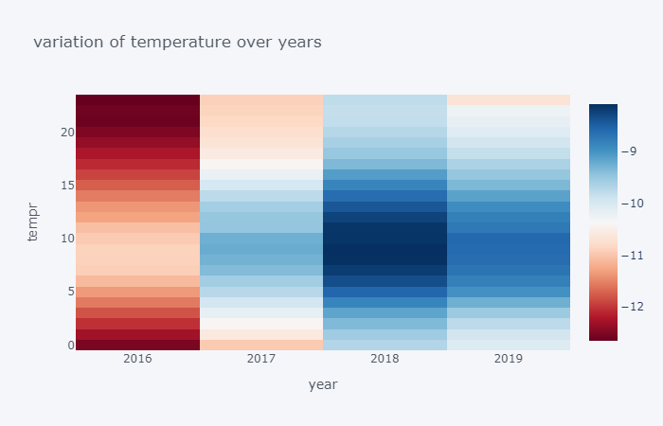

Fig 1

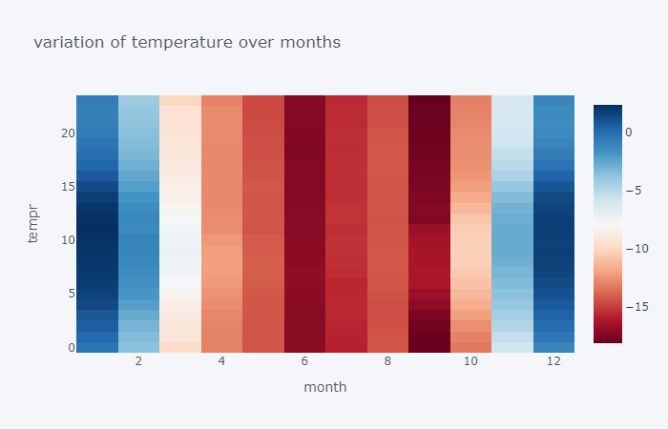fig 2

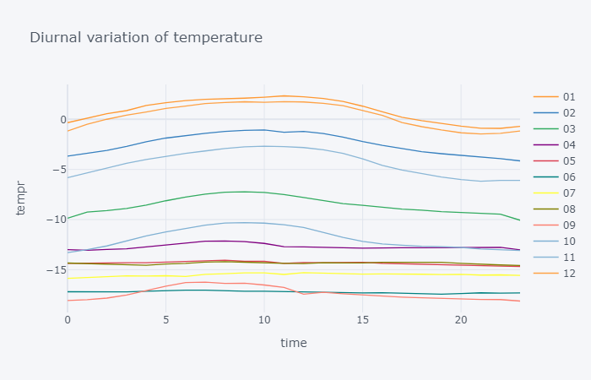

Fig 3

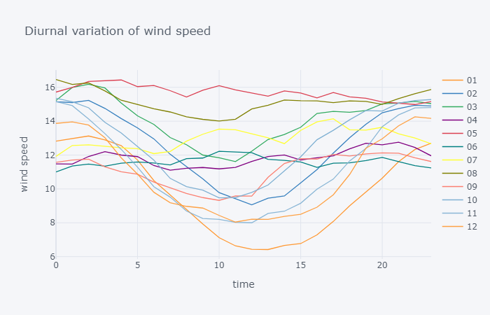fig 4

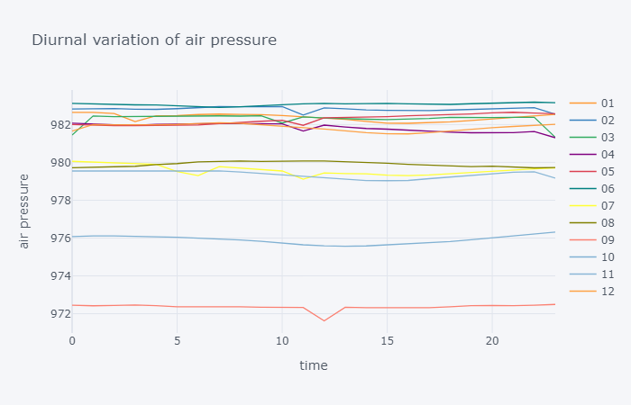fig 5

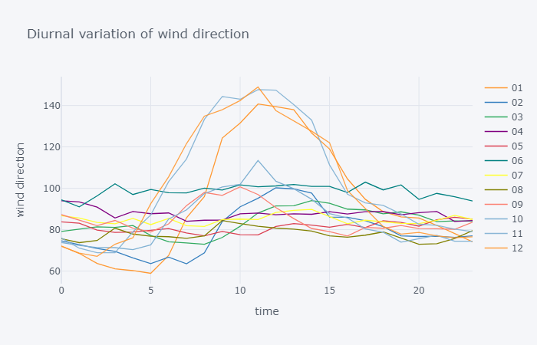

Fig 6

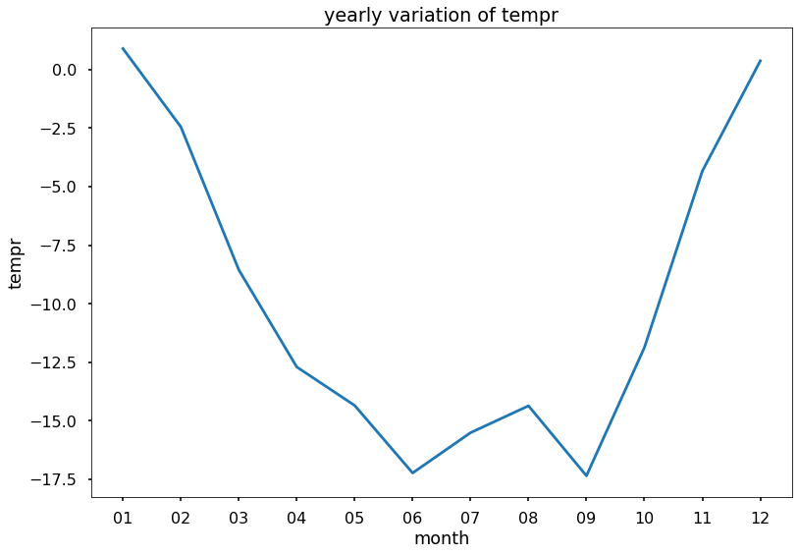fig 7

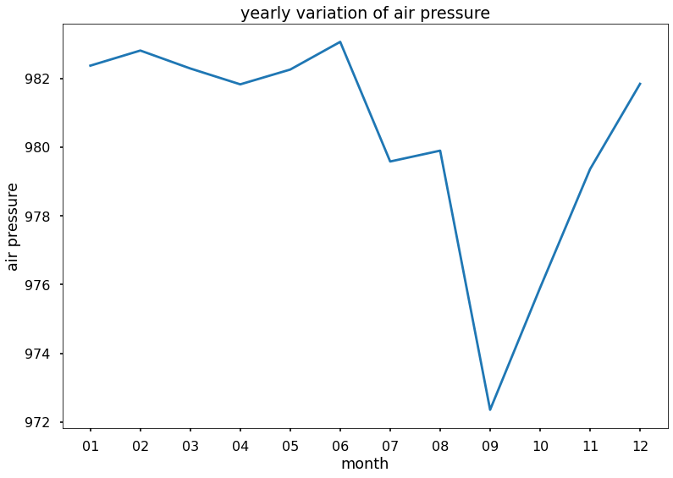fig 8

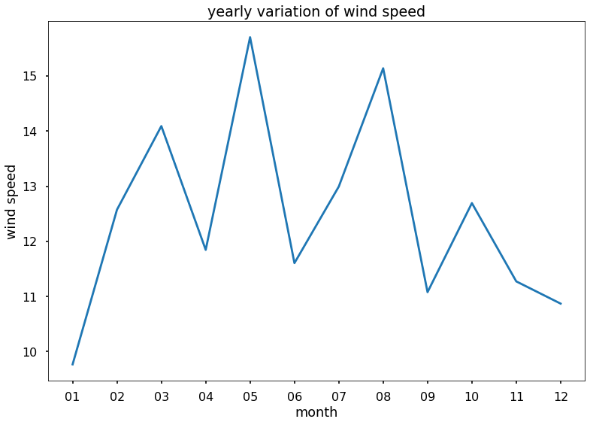

Fig 9

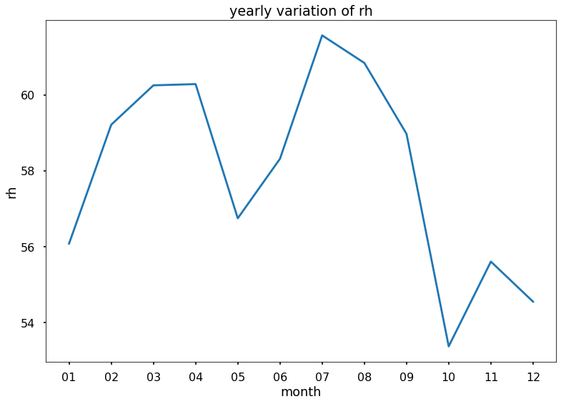

fig 10

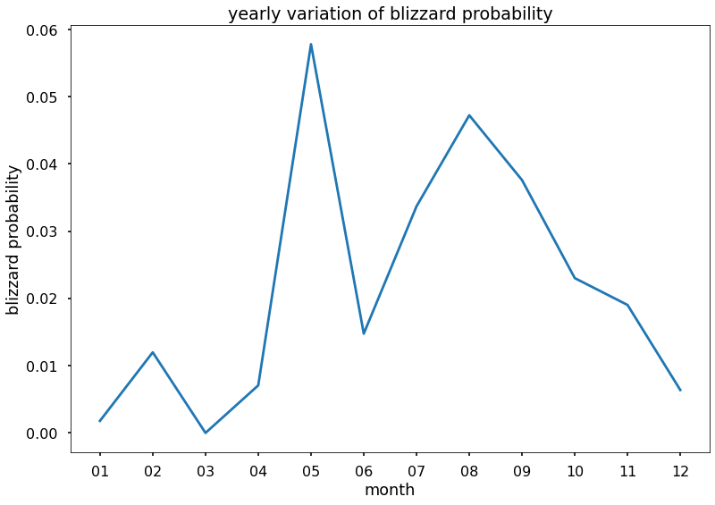

Fig 11

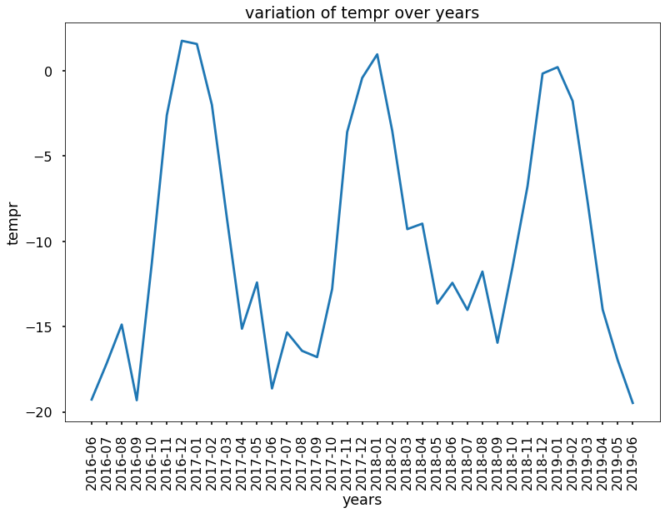fig 12

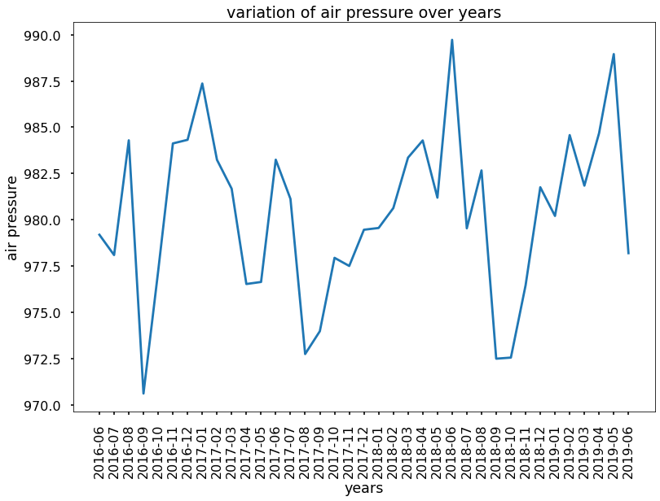fig 13

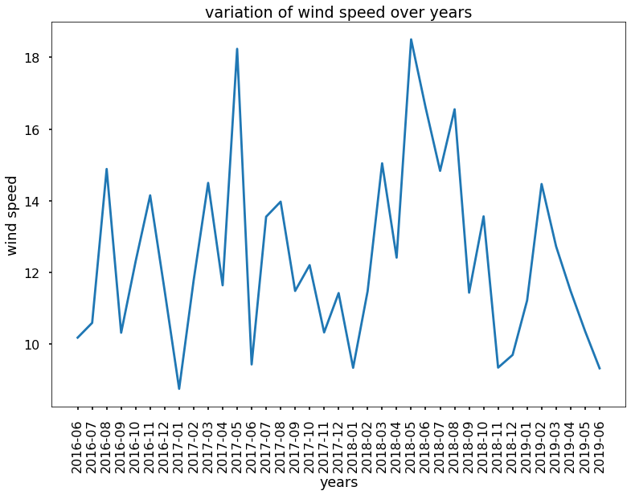fig 14

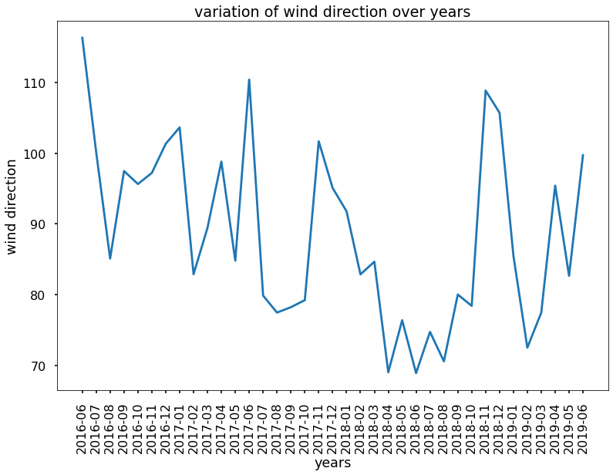fig 15

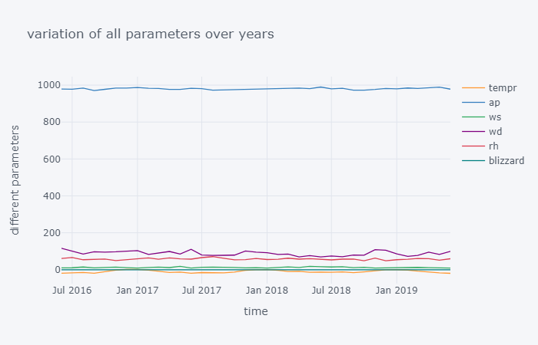fig16

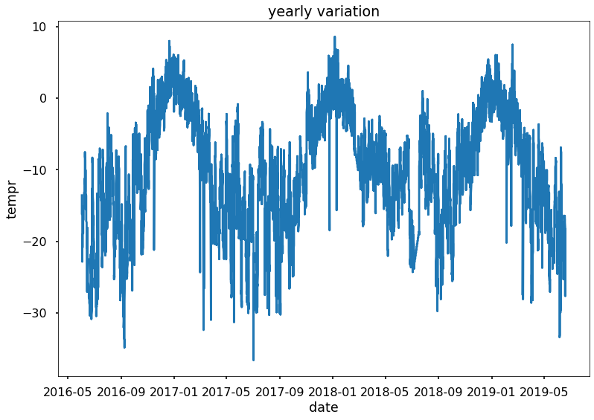fig 17

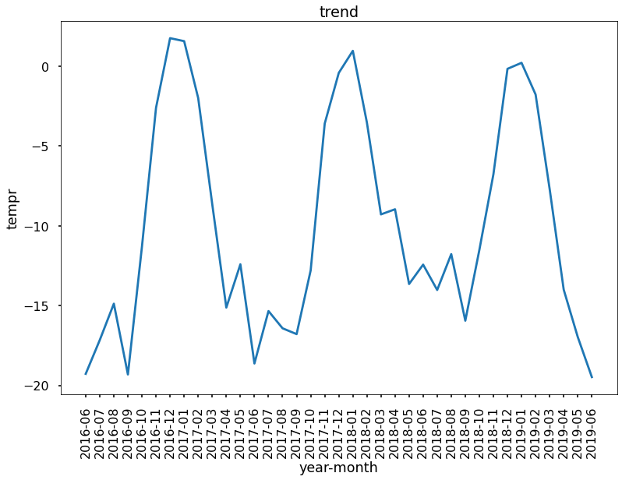fig 18

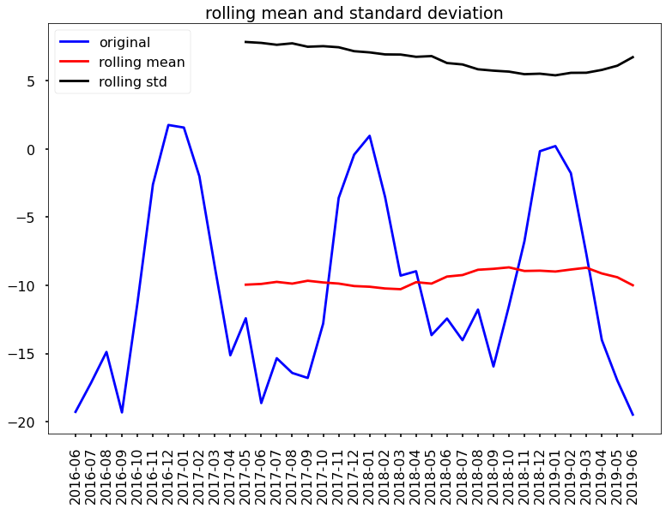fig 19

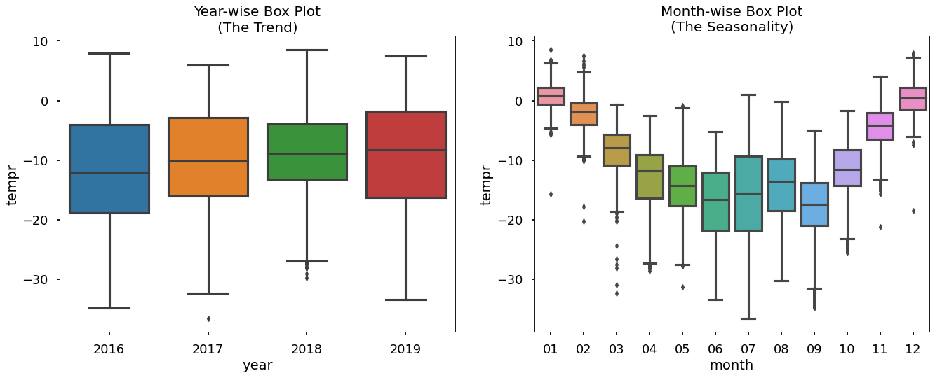fig 20

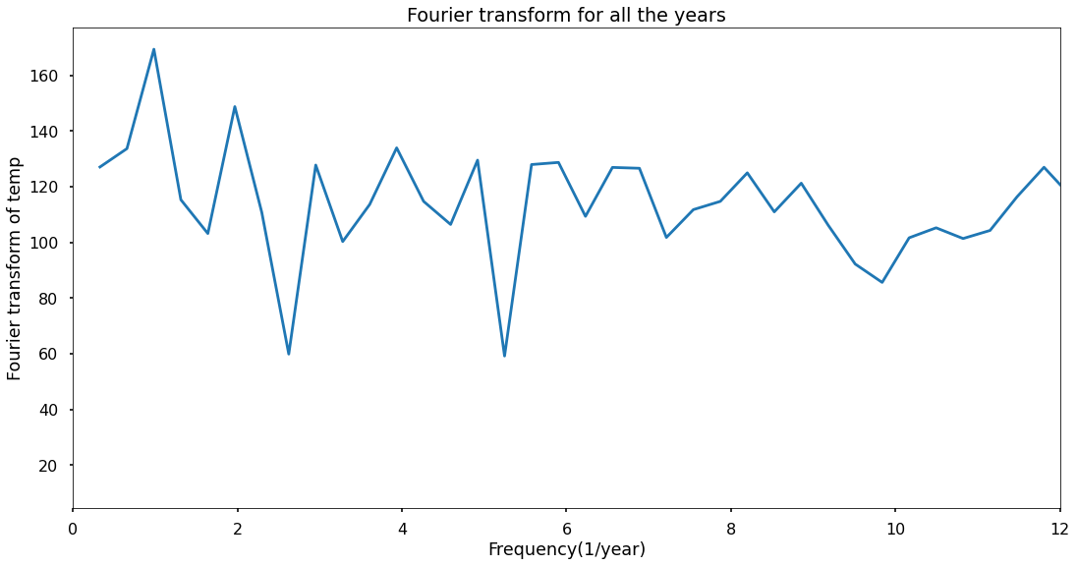fig 21

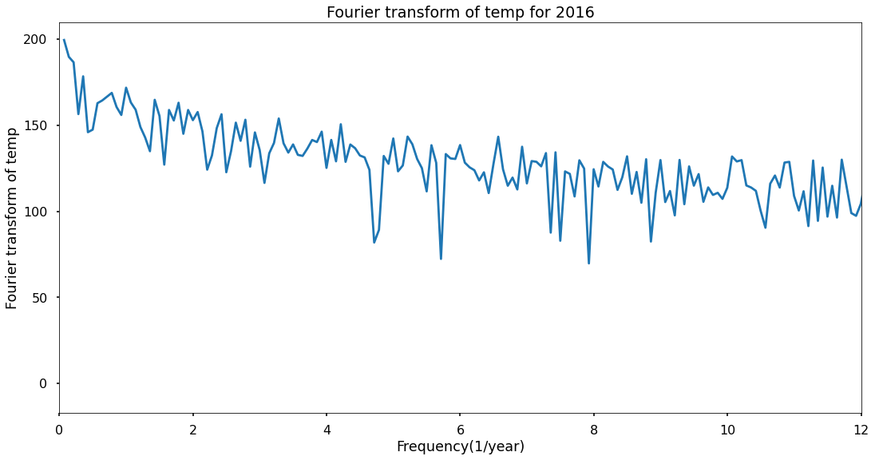fig 22

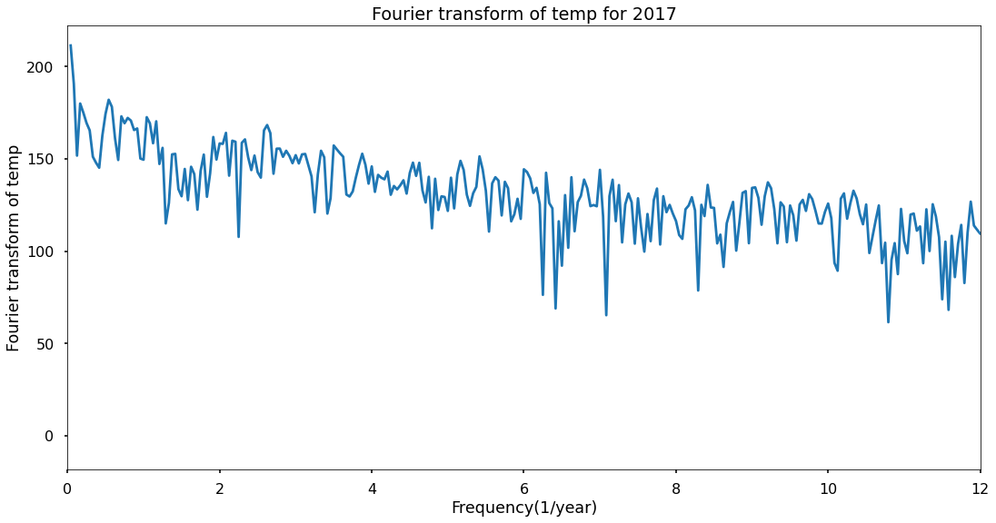fig 23

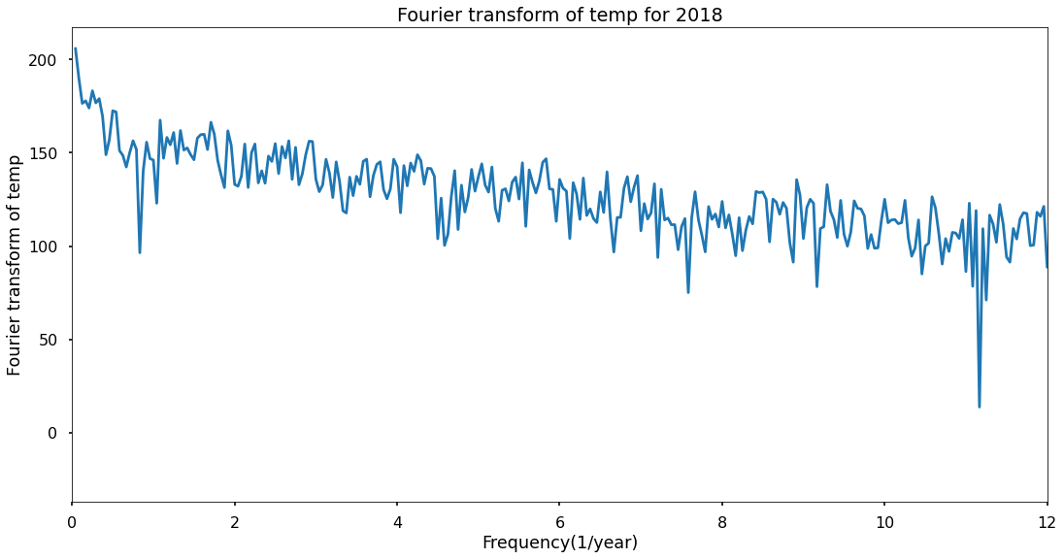fig 24

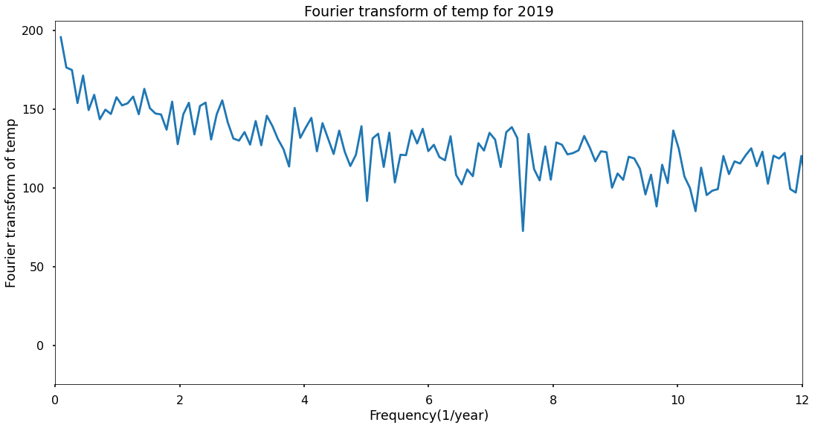fig 25

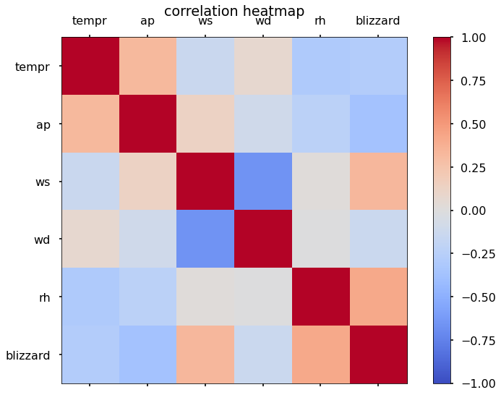

Fig 26

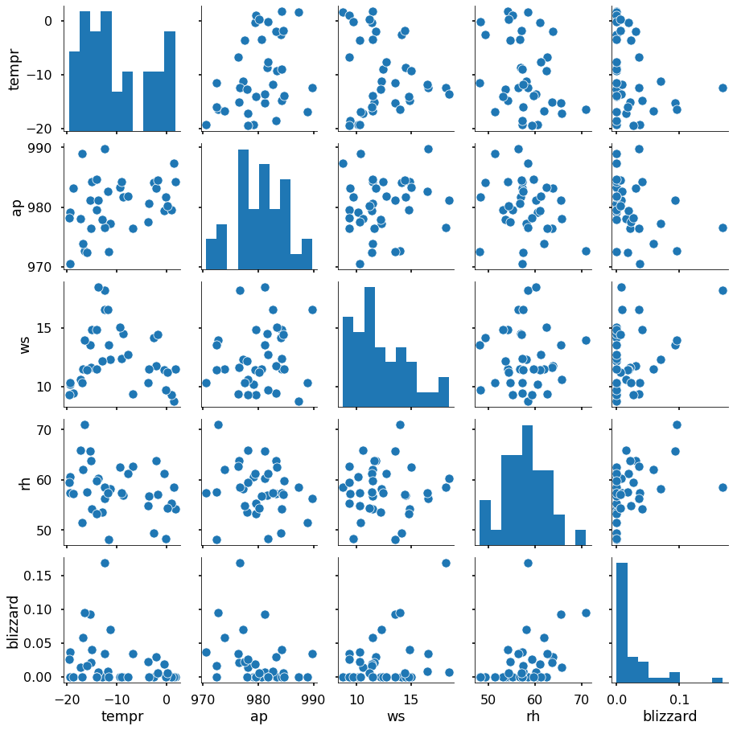

Fig 27

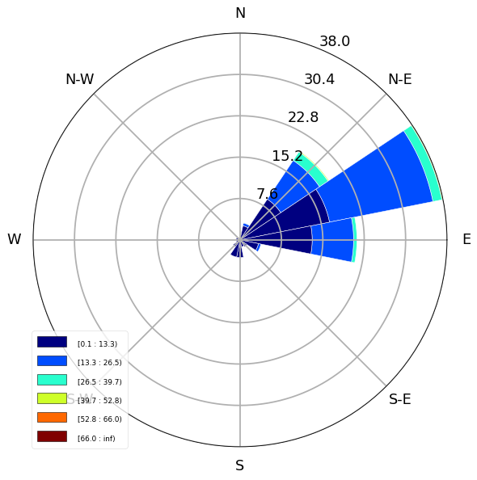

Fig 28